## Admin shall be able to log into CHP-IVT

|  |  |  |
| --- | --- | --- |
|  | | |
| **Requirements ID:** REQ0005-AdminLogIn | | |
| **Primary Actors:** Admin, CPH-IVT | | |
| **Use Case Name:** Log into system | | **Importance Level:** High |
| **Stakeholders:** | Administrators, Aides, Developers | |
| **Requirement:** | The Admin shall be able to log into CPH-IVT using his/her <login credentials>. | |
| **Story:** | As an Admin, I want to be able to log into CPH-IVT, so I can manage the ETSU College of Public Health | |
| **Quality Requirements:** | The Admin shall be able to log into CPH-IVT using his/her <login credentials> in sixty seconds or less. | |
| **Pre-Conditions:** | 1. I am an Admin  2. A web browser instance is open | |
| **Post-Conditions:** | Success:   1. I am on CPH-IVT start page 2. I can see the ‘administrative dashboard’ at <host>/home   Failure:   1. I am not on CPH-IVT 2. I can not see the CPH-IVT ‘login page’ at <host> | |
| **Relationships:** | None (This requirement is atomic) | |
| **Trigger:** | **Trigger Type:** External  I request the CPH – IVT ‘admin page’ at <host> | |
| **Normal Flow of Events:** | 1. CPH-IVT responds with the ‘admin page’ 2. I enter my <login credentials>   2.1 Enter Email (See Alternative flow: Enter username)  2.1.1 <ETSU email>:: [a-z]+[0-9]*@etsu.edu  2.2 Enter password  2.2.1 <password> :: 8{[A-Z]+[a-z]+[\d]+[@$!%*?&]+)}24  3. I issue the ‘log in’ command  4. CPH -IVT validates my <login credentials> (See Exception flow: Invalid login credentials)   5. CPH-IVT responds with my ‘administrative dashboard’ at <host>/home | |
| **Alternative flow:** | [Enter username]   1. Enter username   1.1 <username> :: [a-z]+[0-9]*   1. Enter password   2.1 <password> :: 8{[A-Z]+[a-z]+[\d]+[@$!%*?&]+)}24   1. I issue the ‘log in’ command 2. CPH-IVT validates my <login credentials> (See Exception flow: Invalid login credentials) 3. CPH-IVT responds with my ‘administrative dashboard’ at <host>/home | |
| **Exception flow** | [Invalid login credentials]   1. CPH-IVT is unable to validate my <login credentials> 2. CPH-IVT responds with the ‘login page’ at <host> 3. CPH-IVT displays an error message above the ‘enter login credentials’ form   3.1 “Invalid username/password. Please try again.” | |
| **Storage Requirements** | **Host**  <host>:: notsupplied.etsu.edu  **Login Credentials**  <login credentials>:: <ETSU email>|<username><tab><password>  <ETSU email>:: [a-z]+[0-9]*@etsu.edu  <username>:: [a-z]+[0-9]* <password>:: 8{[A-Z]+[a-z]+[\d]+[@$!%*?&]+)}24 | |

**Behavioral Flow**

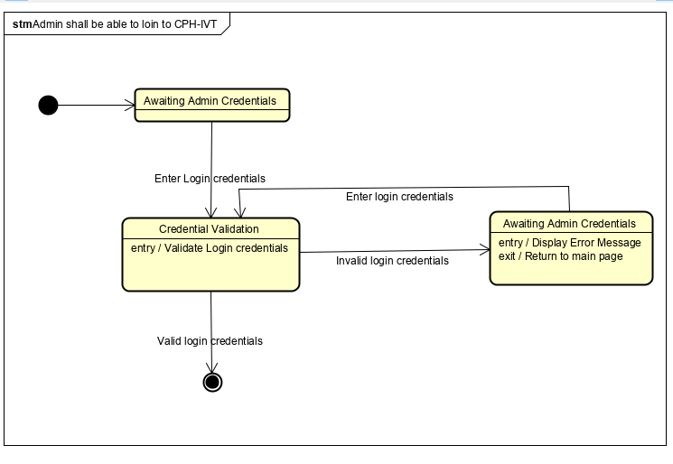

**Data Elements**

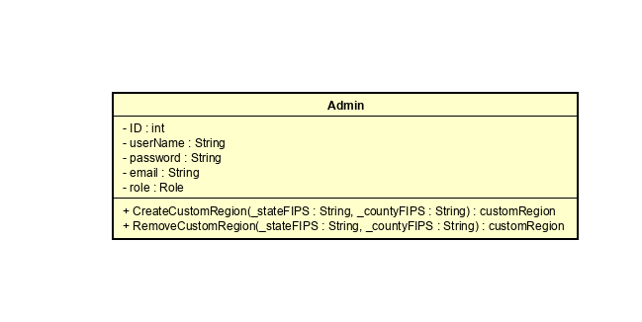

**UI Prototype**

